US History: Thematic Essay

This packet helps breakdown the US History Regents Thematic Essay by going over the major thematic essay themes and topics. Below is a list of the main thematic essay topics. Each page has an example essay for the topic. Your job is to OUTLINE the essays by using your memory, notes, books, teacher, and the internet for help.

Major US Thematic Essay Topics:
1. Change/Turning Points
2. Civic Values and Laws
3. Constitutional Principles
4. Culture and Intellectual Life
5. Diversity and Equality
6. Economic Systems
7. Foreign Policy
8. Geography
9. Government Branches
10. Human Systems in Society
11. Immigration and Migration
12. Presidential Actions and Decisions
13. Science and Technology
14. Supreme Court Cases
15. Individuals, Groups, and Institutions

When outlining your essay in this packet, and when writing full essays on the Regents, be sure to remember the guidelines below. This is what your teachers’ grade you on in class and on the regents!

Guidelines for writing a Thematic Essay:
- Develop all aspects of the task
- Show a thorough understanding of the theme
- Support the theme with relevant facts, examples, details, and information
- Shows an ability to analyze, evaluate, compare, and/or contrast the theme
- Is well developed and uses a clear plan of logical organization, including an introduction and a conclusion that are beyond a restatement of the theme

Sample:

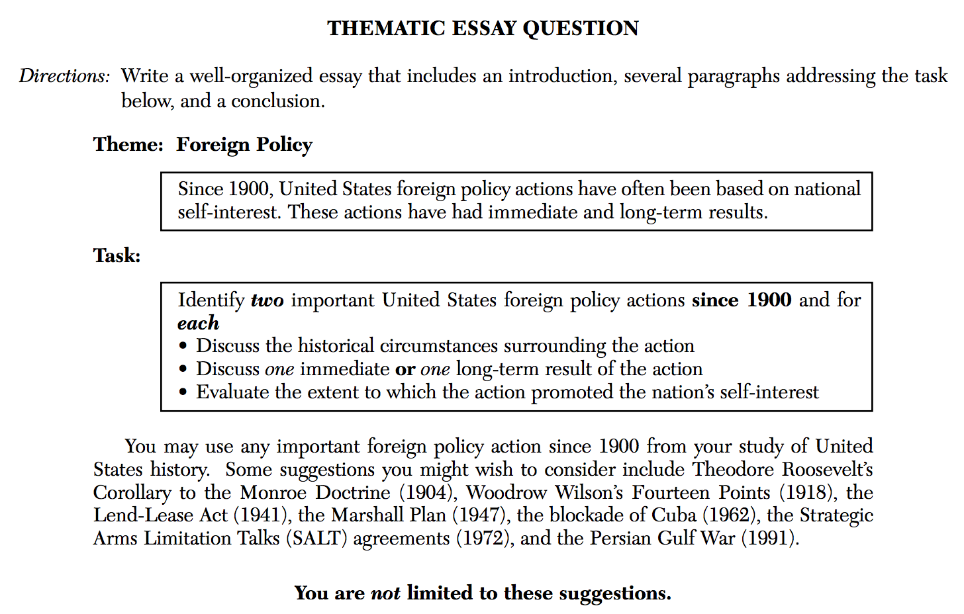

Each group will be assigned a common thematic essay question from a previous US History Regents exam.

In your small groups, I want you to OUTLINE your assigned thematic essay according to the model below.

Each outline should include details and outside information that you would add into your essay if this was the day of the Regents exam.

When all groups are finished, we will hang up the outlines around the room, and everyone will have an opportunity to walk around (take a picture) and use the outline to study from!

1. Theme: Change/Turning Points

Historical Context:
Throughout US History, many political, social, and economic changes occurred.

Task:
Identify two major turning points in your study of US History and for each,
• Explain the historical circumstances that brought about the turning point
• Describe two ways that the turning point changed America
• Evaluate the impact that the major change had on American society

You may use any major event from your study of United States history. Some suggestions you might wish to consider include the signing of the Declaration of Independence (1776), end of Reconstruction (1877), Henry Ford’s use of the assembly line (1913), United States entry into World War I (1917), Brown v. Board of Education of Topeka (1954), passage of the Gulf of Tonkin Resolution (1964), and the fall of the Berlin Wall (1989).

You are not limited to these suggestions. Do not use topics from outside the United States.

2. Theme: Civic Values and Laws

Historical Context:
Throughout US History, many laws have been created to deal with various issues.

Task:
Identify two federal laws from your study of US History and for each
• Describe the historical circumstances that led to the law
• Describe one way the law changed America
• Evaluate the impact that the law had on American society

You may use any federal law from your study of US history, except amendments. Some suggestions you might wish to consider include the Northwest Ordinance Act (1787), Alien and Sedition Act (1798), Indian Removal Act (1830), Homestead Act (1862), Freedman’s Bureau Act (1865), Chinese Exclusion Act (1882), Dawes Act (1887), Sherman Anti-Trust Act (1890), Immigration Act (1903), Meat Inspection Act (1906), GI Bill (1944), and Equal Pay Act (1963).
You are not limited to these suggestions. Do not use topics from outside the United States.

3. Theme: Constitutional Principles

Historical Context:
When the founding fathers of America wrote the U.S. Constitution, certain principles were set up to guide the country and the U.S. Government.

Task:
Select two Supreme Court cases that have affected American society. For each case selected:
• Discuss the historical circumstances of the case
• Explain the Court’s decision in the case
• Discuss the impact of the decision on American society

You may use any example from your study of United States history. Some suggestions you might wish to consider include: McCulloch v. Maryland (1819) — federal supremacy Schenck v. United States (1919) — freedom of speech Korematsu v. United States (1944) — equal protection under the law Brown v. Board of Education of Topeka (1954) — equal protection under the law Engel v. Vitale (1962) — separation of church and state Miranda v. Arizona (1966) — rights of the accused Roe v. Wade (1973) — right to privacy Vernonia School District v. Acton (1995) — search and seizure
You are not limited to these suggestions. Do not use topics from outside the United States.

4. Theme: Culture and Intellectual Life

Historical Context:
Throughout US History, many works of literature have been published that have influenced public opinion toward many various topics.

Task:
Identify two major publications from your study of US History and for each
• Explain the situation or event that the publication was written for
• Describe one action taken by the government to deal with the situation
• Evaluate the success that the publication and government action had in dealing with the situation

You may use any publication from US history. Some suggestions you might wish to consider include Thomas Paine’s Common Sense, Alexander Hamilton’s Federalist Papers, Harriet Beecher Stowe’s Uncle Tom’s Cabin, Upton Sinclair’s The Jungle, Jacob Riis’ How the Other Half Lives, Langston Hughes’ I Too Sing America, F. Scott Fitzgerald’s The Great Gatsby, John Steinbeck’s The Grapes of Wrath, and Rachel Carson’s Silent Spring.
You are not limited to these suggestions. Do not use topics from outside the United States.

5. Theme: Diversity and Equality

Historical Context:
Throughout US History, the rights of “life, liberty, and the pursuit of happiness,” as stated in the Declaration, have often been denied to groups of Americans.

Task:
Identify two major groups from your study of US history and for each
• Use two historical examples to show how the group has been denied their rights
• Discuss one effort that has been made to help the group attain their rights
• Evaluate the extent to which the group has achieved equality today

You may use any diverse group from your study of US history. Some suggestions you might wish to consider include Native Americans, African Americans, Asian Americans, Hispanic Americans, Muslim Americans, and women in America.
You are not limited to these suggestions. Do not use topics from outside the United States.

6. Theme: Economic Systems

Historical Context:
Throughout US History, many different economic systems and programs have been used for various reasons to deal with the wants and needs of people.

Task:
Identify two major economic programs from US History and for each
• Discuss the historical circumstances surrounding the economic program
• Describe two features of the economic program
• Evaluate the positive or negative impact the economic program had on America

You may use any economic program from your study of US history. Some suggestions you might wish to consider include mercantilism, slavery, free market capitalism, monopolies and trusts, labor unions, the New Deal, the Great Society, and Supply Side Economics.
You are not limited to these suggestions. Do not use topics from outside the United States.

7. Theme: Foreign Policy

Historical Context:
Throughout US History, many different foreign policies have been used to achieve goals outside of America.

Task:
Identify two major United Sates foreign policies and for each
• Describe what the foreign policy was
• Describe one specific action or program the United States had used to carry out the foreign policy
• Evaluate the extent to which the action or program used was successful in carrying out the foreign policy

You may use any foreign policy from your study of US history. Some suggestions you might wish to consider include Westward Expansion, the Monroe Doctrine, the Mexican-American War, US Imperialism, US entry into WWI, Wilson’s 14 Points, US entry into WWII, Containment during the Cold War, the Korean War, the Vietnam War, and the Gulf Wars.
You are not limited to these suggestions. Do not use topics from outside the United States.

8. Theme: Geography

Historical Context:
Throughout US History, geography influenced many of the actions taken by the United States to expand its territory or protect its national interests.

Task:
Identify two events in American history that involve geography and for each
• Describe two facts about the event involving geography
• Explain the influence of geography or geographic significance of the event on American history
• Evaluate the positive and/or negative impact of the event on the US

You may use any geographic event from your study of US history. Some suggestions you might wish to consider include the Northwest Ordinance, the Louisiana Purchase, the Lewis and Clark Expedition, the War of 1812, the Monroe Doctrine, the Purchase of Florida, the Missouri Compromise, the Erie Canal, the Mexican-American War, the transcontinental railroad, the Alaska Purchase, the Homestead Act, the Spanish-American War, and American Imperialism.

You are not limited to these suggestions. Do not use topics from outside the United States.

9. Theme: Government Branches

Historical Context:
As America’s founding fathers were creating the U.S. Constitution, the federal government’s powers were divided up among three federal branches.

Task:
Identify two of the three federal government branches of government and for each
• Explain who is in the branch, how they are chosen, and what they do with laws
• Describe two responsibilities and/or powers of the federal branch
• Give a specific historical example of an action, program, law, or case in which the federal branch used their power

You may use any major federal government branch from your study of US history. Some suggestions you might wish to consider include the Legislative, the Executive, and the Judicial.
You are not limited to these suggestions. Do not use topics from outside the United States.

10. Theme: Human Systems in Society

Historical Context:
Throughout US History, people worked to improve their lives and American society in various ways using human systems.

Task:
Identify two major human systems in your study of US History and for each
• Describe what the human system is and what it is supposed to do
• Describe two ways that the human system changed American society
• Evaluate the positive and/or negative impact of the human system on the US

You may use any major social system from your study of US history. Some suggestions you might wish to consider include colonization, industrialization, capitalism, imperialism, Social Darwinism, Progressivism, immigration, urbanization, unionization, and Prohibition.
You are not limited to these suggestions. Do not use topics from outside the United States.

11. Theme: Immigration and Migration

Historical Context:
Throughout US History, many groups of people have immigrated to the United States for various reasons.

Task:
Identify two major groups that have immigrated to America and for each
• Describe the historical circumstances that led group immigrated to the US
• Discuss the impact of the migration on the US

You may use any major migration from your study of US history. Some suggestions you might consider include colonial settlement (1600’s-1700’s), westward expansion (1800’s), rural to urban migrations (1870’s-1920’s), Eastern European immigration (1880-1910), the Dust Bowl migrations (1930’s), suburbanization (1950’s-1960’s), Hispanic immigration (1960’s-modern), and illegal immigration (1990-modern).
You are not limited to these suggestions. Do not use topics from outside the United States.

12. Theme: Presidential Actions and Decisions

Historical Context:
Throughout US History, US Presidents have made important decisions and performed important actions in an effort to solve crucial problems.

Task:
Identify two major US presidential decisions and for each
• State one goal the President hoped to accomplish by making the decision
• Describe the extent to which the decision achieved the President’s goal
• Discuss the effect of the decision on the course of US History

You may use any presidential action and/or decision from your study of US history. Some suggestions you might wish to consider include William McKinley calling for war with Spain (1898), Franklin D. Roosevelt’s New Deal Program (1933), Harry Truman’s decision to drop the atomic bombs on Japan (1945), Dwight D. Eisenhower sending Federal troops to Little Rock, Arkansas (1957), John F. Kennedy’s naval blockade of Cuba (1962), Lyndon Johnson’s Great Society program (1965), and Jimmy Carter’s Camp David Accords (1978).
You are not limited to these suggestions. Do not use topics from outside the United States.

13. Theme: Science and Technology

Historical Context:
Throughout US History, technological developments have had both positive and negative effects on the US economy and on American society

Task:
Identify two major technological developments and for each
• Describe what the technological development was
• Evaluate the positive and/or negative effects of the technological development on the US economy or on American society

You may use any scientific advance and/or technology from your study of US history. Some suggestions you might wish to consider include the cotton gin, steamboats, the telegraph, the Erie Canal, the railroad, industrialization, the assembly line, the automobile, satellites, vaccines, and nuclear power.
You are not limited to these suggestions. Do not use topics from outside the United States.

14. Theme: Supreme Court Cases

Historical Context:
Throughout US History, the Supreme Court has played a major role in either expanding or limiting constitutional civil liberties in the United States.

Task:
Identify two major Supreme Court cases that had an impact on civil liberties in the US and for each
• Discuss the basic facts of the case
• Identify a specific constitutional liberty issue addressed by the Supreme Court
• Evaluate how the decision of the Supreme Court either expanded or limited a specific constitutional civil liberty in the US

You may use any Supreme Court Case from your study of US history. Some suggestions you might wish to consider include the Peter Zenger Trial (1734), Marbury v. Madison (1803), McCulloch v. Maryland (1819), Dred Scott v. Sanford (1857), Plessy v. Ferguson (1896), Scopes v. Tennessee (1925), Schenck v. US (1919), the Sacco and Vanzetti Trial (1920), Korematsu v. US (1944), Brown v. Board of Education (1954), Miranda v. Arizona (1966), Tinker v. Des Moines (1969), Roe v. Wade (1973), and New Jersey v. T.L.O. (1985).
You are not limited to these suggestions. Do not use topics from outside the United States.

15. Theme: Individuals, Groups, and Institutions – Controversial Issues

Historical Context:
Many controversial domestic issues have divided the American people. The United States government has taken actions to address these issues.

Task:
Identify one controversial domestic issue that has divided the American people and
• Discuss the historical background of the controversy
• Explain the point of view of those who supported this issue
• Explain the point of view of those who opposed this issue
• Discuss one United States government action that was taken to address this issue

You may use any controversial domestic issue that has divided the American people. Some suggestions you might wish to consider include placing Native American Indians on reservations, slavery, women’s suffrage, Prohibition, the use of child labor, and the policy of unlimited immigration.

You are not limited to these suggestions.

Other US history essays
http://web001.greece.k12.ny.us/academics.cfm?subpage=29878#Supreme%20Court%20Cases%20Thematic%20Essay%2006.02

