US History Regents Review Sheet!
Not everything you need, but a ton of it!

Most commonly seen topics/information on the exam:

1. If you see: House of Burgesses, Mayflower Compact, Colonial town meetings
ANSWER: “early forms of representative democracy” OR “self-governments” OR early “republics”

2. If you see: John Marshall
ANSWER: He EXPANDED the power of the federal government through THESE following court cases…
- “judicial review” = Marbury v. Madison (1803)
- “Congress’ right to charter a bank”/ “The power to tax is the power to destroy!” = McCulloch v. Maryland (1819)
- “federal government controls interstate commerce” = Gibbons v. Ogden (1824)

3. Why did immigrants in the 1800s/1900s and African Americans (during WWI and WWII-Great Migration) move to cities?? THERE WERE JOBS!

4. If you see: Nativism = ANTI-FOREIGN SENTIMENT
ANSWER:
- Creation of quota systems to limit immigration into the United States.
- They FAVORED WESTERN EUROPEANS (England, Ireland, etc.) who spoke English and had similar religious views.
- It DID NOT FAVOR EASTERN EUROPEANS (Russia, Poland, etc.) who had a different language and religious views.
- If you see a question with the “Chinese Exclusion Act” or “Sacco and Vanzetti”, these could have nativism as an answer.

5. If you see: George Washington
ANSWER: “neutrality” OR “isolation” OR “noninvolvement”
- Remember his Proclamation of Neutrality (1793)
- Remember his Farewell Address (1796)
  - No political ties to other nations
  - No permanent alliances with other nations
  - No political parties

6. If you see: Why was the Articles of Confederation created (1777)?
ANSWER: Fear of a strong government (another monarchy) OR more power to the STATES
- Led to the “critical period” – Shays’ Rebellion and other events of protest

7. If you see: Domino Theory (for Asia), Truman Doctrine, Marshall Plan, Korean War, NATO ...
Answer: CONTAINMENT of COMMUNISM during the Cold War!

8. If you see: World War II = Lend-Lease Act, plus Cash and Carry.
Answer should be: a move away from isolationism -- becoming less neutral. Pearl Harbor and D-Day occasionally come up (D-Day will usually have an answer about opening up a new front in Europe during the war).

9. If you see: Why didn't we ratify the Treaty of Versailles? = Neutrality and Isolation! We did NOT want to join the international League of Nations!

10. If you see: Federalism
ANSWER: DIVISION OF POWER between the federal governments and state governments
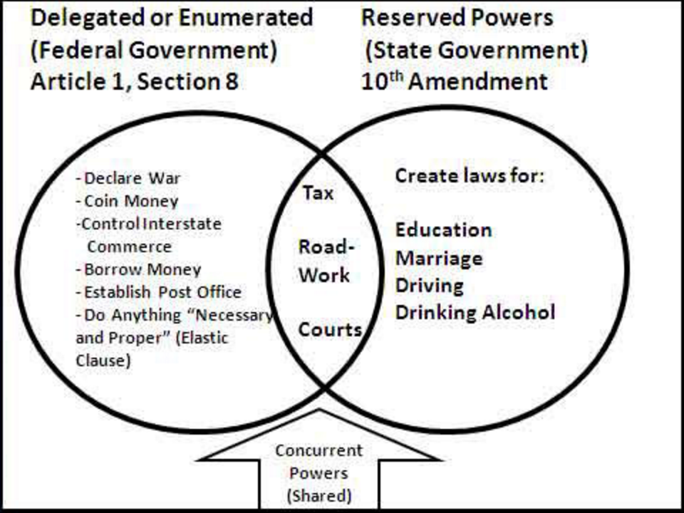
**Don’t confuse federalism with CHECKS AND BALANCES
- Checks and balances = checking the 3 branches of the FEDERAL government (Legislative, Executive, Judicial)
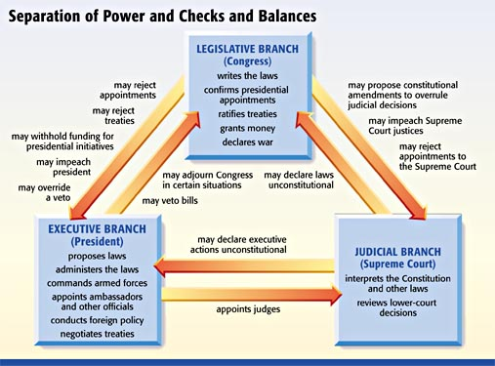

11. If you see: UNWRITTEN CONSTITUTION
Answer: These are customs and traditions that the US GOVERNMENT DOES, BUT which aren't printed in the Constitution (such as having political parties, holding cabinet meetings, judicial review, lobbying, and nominating election conventions).
> Limiting the President’s time in office to two terms was established under the unwritten constitution and later included in the written Constitution.

12. We got involved in WWI because of "the Boat, and the Note." (Lusitania, and Zimmerman Telegram).

13. If you see: TRUSTS or MONOPOLIES
Answer: Makes the rich get richer! They ELIMINATE COMPETITION TO GET RICH! Bought up smaller competitors until they dominated the industry. ALSO…widened the gap between the RICH and POOR!

> Solution? The Sherman Anti-Trust Act tried to bust the trusts! If you see Unions (or American Federation of Labor - AFL, Sherman Anti-Trust, or COLLECTIVE BARGAINING) ... Answer: "to help the small guy and consumer out” or allow for more fair business competition.

14. To repeal an amendment ... Congress must ratify (approve) another amendment (like the 18th and 21st for prohibition.)
> Speaking of ratifying ... think Federalist Papers were created in order to persuade Americans for ratification of the NEW CONSTITUTION (1788)!

16. If you see: Manifest Destiny = led to the question --should these states be slave or free? This was the BIG DEBATE! STATES’ RIGHTS were the issue…is it their right to choose whether they are slave or free?? How do they choose??
> Manifest Destiny also settles the Frontier ... If you see transcontinental railroad the answer is usually about increased trade, opening up a national market and settlement of the west!

16a. Also, remember the plans for Reconstruction we spoke about? (should have a 3 column chart in your notes…) After the Civil War, Abraham Lincoln and Andrew Johnson had their Presidential (lenient, forgiving the South because they technically never left the Union) Reconstruction plans vs. the Radical Republicans (harsh on South, divide the South into 5 military districts to be watched over, for African American rights!) Reconstruction plans.

17. REMEMBER: Questions 1-3 usually have something to do with geography.
> What you might see:
- Mississippi River led to trade and navigation
- New England colonies had trade and constructed their settlements around harbors and bodies of water for trade
- The South was agricultural because of warmer temperatures and fertile soil
- The Great Plains were flat
- New Orleans (part of the Louisiana Purchase) was a port for trade up and down the Mississippi River

18. If you see: How did the US respond to massive immigration?
Answer: The QUOTA SYSTEM is usually the answer. This ties into nativism, and how Americans who were angry about Immigrants taking jobs from Americans and working for cheaper wages. Wanted the adoption of a quota system to limit immigration.
> You could see: Chinese Exclusion Act (1882)- Limited the amount of Chinese immigrants entering the U.S. An example of Nativism.
> Other immigration info leading to nativism:
- Large numbers of immigrants were admitted to the U.S. during most of the 1800’s because the economy needed many unskilled factory workers. Factory owners strongly supported an open immigration policy in order to get cheap labor.
- Immigration increased from Ireland to the U.S. during the 1840’s due to crop failures (Irish Potato Famine) in Ireland that led to mass starvation. During the 1850’s, Irish immigrants were discriminated against because they practiced the Roman Catholic Religion.
- New Immigrants- Came primarily from southern and eastern Europe (Ex: Italy & Russia) between 1890-1915. Were culturally different from the earlier immigrants. Many believed they would fail to assimilate into American society.

19. If you see a cartoon with FDR and the Supreme Court: FDR’s COURT-PACKING plan! It’s usually a question with a political cartoon. He tried to pack the court with his friends to support his NEW DEAL programs…but he never did it in the end. It was seen as FDR trying to overstep his presidential boundaries and getting TOO STRONG!

20. If you see: MUCKRAKERS…think names like Jacob Riis, Upton Sinclair (The Jungle/meatpacking industry), Ida Tarbell.
Answer: most likely about cleaning up society and regulating big business to protect the people/consumers!
> Also be aware of political cartoons showing how a president (like Teddy Roosevelt!) tried to clean up society by working to pass legislation like the Meat Inspection Act (The Jungle) and the Pure Food and Drug Act (1906)

21. If you see: Lyndon Johnson and the Great Society...look for something about the government helping the poor (remember LBJ’s War on Poverty)
> Compare it to: FDR’s New Deal that looked to create jobs (public works) and help people socially and economically!

22. Ronald Reagan cut taxes for the rich with "Reaganomics” (supply-side economics) and hoped the profits would “trickle-down” to the poorer classes, but it didn’t happen as planned! Led to economic troubles (recession) that would hurt George HW Bush’s presidency!

23. If you see: terms like initiative, referendum, or recall
Answer: states expanding democracy during the Progressive Era/people have more direct control over voting/increasing American people’s participation in government.
> Direct Election of Senators- Established by the 17th amendment (1913) = citizens directly voted on who would represent them in the Senate in order to make the Senate more responsive to the people.

24. If you see: The Great Compromise (1787) or 3/5 Compromise (1787)
Answer: something about representation, or the population determining representation in the House
> Great Compromise = creating a 2-hour Congress, and this bicameral legislature would protect the power of both the large states and the small states.
25. Not often, but if you see: Cesar Chavez...Think "Caesar Salad" -- he fought for the rights of farmers.
Another name to know is: Rachel Carson. Her book Silent Spring helped start the environmental movement. Spring = Nature (Other names to link with Rachel Carson who loved conserving nature were Teddy Roosevelt and John Muir)

26. If you see: Seneca Falls = It's a women's conference (1848)! Women love to go to the Falls, it's romantic. Think of womens’ names like Lucretia Mott and Elizabeth Cady Stanton and Susan B. Anthony.

27. Langston Hughes starts with an H….and so does Harlem Renaissance! If there's an African American culture movement question, Hughes can be the answer. Also consider names like Louis Armstrong, Marcus Garvey, and Duke Ellington.

28. If you see: Miranda v. Arizona, Gideon v. Wainwright - These cases expanded the rights of the accused!

