HARRIET TUBMAN

Background:
Harriet Tubman was born a slave, her parents named her Araminta “Minty” Ross. She changed her name in 1849 when she escaped. She adopted the name Harriet after her mother and the last name Tubman after her husband. Tubman suffered a head injury as a teenager which gave her vivid dreams and hallucinations, in addition to sleeping spells. She was deeply religious and according to her it was her religious beliefs that gave her courage rescue friends and family over and over again. She remained illiterate for her entire life.

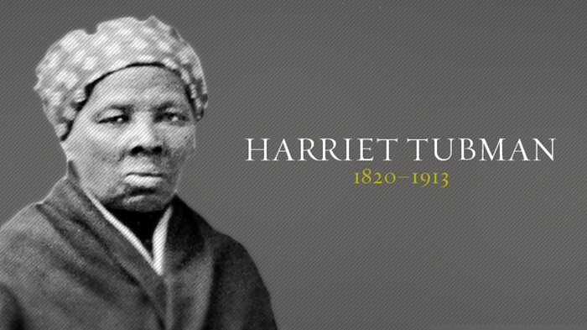

THE UNDERGROUND RAILROAD

The Underground Railroad was a network of safe houses and transportation provided by abolitionists. The network was loosely organized and usually owners of safe houses did not know the entire network but just a few connecting stations. Over a period of time, Tubman was able to build her own network of connections with friends she trusted and who admired her. Secrecy was paramount. For those who decided to shelter slaves, the consequence of getting caught was going to jail for 6 months.

To her, freedom felt empty unless she could share it with people she loved so she resolved to go back and rescue friends and family. Harriet was nicknamed “Moses” by abolitionist William Lloyd Garrison. The name was used as an analogy to the biblical story of Moses who attempted to lead the Jews to the Promised Land and free them from slavery.

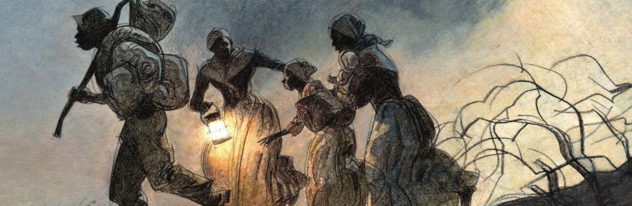

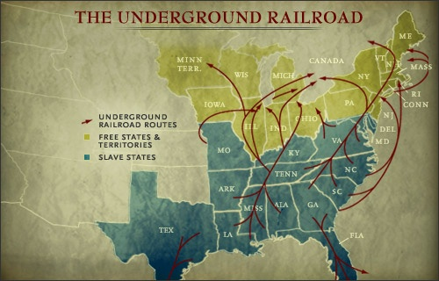

Escape strategies?
Secret code language was used to communicate among Underground Railway supporters. Letters would usually contain code language just in case the letter got intercepted. Since most slaves were illiterate instructions were given by signal songs which had hidden messages only slaves could understand.
- Coded songs contained words giving directions on how to escape or where to meet. They used Biblical references and analogies of Biblical people, places and stories, comparing them to their own history of slavery. For example, “being bound for the land of Canaan” for a white person could mean ready to die and go to heaven; but to a slave it meant ready to go to Canada.

“Conductor” ==== leader of the escape
“Passengers” ==== escaping slaves
“Tracks” ==== routes
“Trains” ==== farm wagons transporting the escaping slaves
“Depots” ==== safe houses to rest/sleep

- “The wind blows from the south today.” = a warning that slave bounty hunters were nearby!
- “A friend of a friend.” = a password used to signal the arrival of fugitives with an Underground Railroad conductor.
- “A load of potatoes.”... “Parcel.” ... “Bundles of wood.” = fugitives are to be expected soon.

To have a head start she urged slaves to escape their masters on Saturday, as Sunday was a day for rest and the owner would not find out until Monday morning.
Tubman always traveled at night and rested during the day, she preferred to travel during the fall season and occasionally in the spring. Summers had longer days.
She followed the North Star and when it was a cloudy night she would observe the moss growing on the north side of dead tree trunks. In order to avoid slave catchers she would use back roads, waterways, mountains and swamps. Tubman always carried a gun for self protection and to urge slaves not to give up.

STORY TIME! The ride on the Underground Railroad
You are a slave and heard that “Moses” is coming to get you. You have heard that song, Sweet Chariot, for two days. Your friend wants to escape, Moses might not have space in her group but will give her instructions on how to get to freedom. Aunty Harriet sent a field agent to make contact with you notifying that she is coming to get you and your family. It is late spring and the days are getting longer. You have to make a life changing decision. If you are caught your master will never trust you again and will make your life more difficult, or he can sell you south where people work their slaves until they are dead. On the other hand if you are successful you will be free. You make the decision to escape, freedom is worth the risk.
She gave you instructions to leave the plantation on Saturday evening. Sunday is your day off and your master would not notice you are gone until Monday, giving you an advantage of two days before they place a reward notice on the newspaper. She told you how to sneak across the bridge and where to meet her.
Aunty Harriet meets you in a prearranged place, you are happy to see her, it has been years since you last saw her. She guides your group through the woods and walk all night, during the day you try to rest. On the second night you arrive to the first station, the house of Sam Green, the man who went to prison for 10 years for possessing a copy of Uncle Tom’s Cabin. Here you and your group rest during a day or two and hide in a secret passage to keep you safe from slave catchers. The stationmaster runs a great deal of danger by sheltering you, he is breaking the law and if caught she can go to jail or pay a hefty fine.
You notice that Aunt Harriet carries a small gun and she tells you she would use it if necessary, it is to encourage those who might otherwise give up but she has never used it.
To safely move to the next station the station master arranges transportation in a wagon. You are disguised as a middle class African American, the rest of your group is hiding in the back covered in hay. They leave you in the woods and you have to make your way north by following the North Star. The first night it was clear but the second night clouds covered the moon and the stars so we had to rely on the moss growing on trees. Harriet tells you that the moss grows on the north side of the trunks of trees so you observe the trunks and continue north. Dry leaves crackle and every step seams louder than the previous one, you are afraid but find courage to keep going. You have to get in the water to avoid being caught; dogs are barking in the distance. Your feet are bleeding after walking for days, suddenly you arrive at a large city called Wilmington. You are hungry and weak and are met by a man named Thomas Garret. Mr. Garret is a famous abolitionist who shelters slaves who come his way and funds Harriet’s trips to the south. Thomas Garret sends you to the Friends Meeting House where you spend a couple of days hiding in the cellar. You get new shoes. You are still a long way to freedom.
After spending a couple of days in Wilmington you are on your way to Philadelphia. You cross the Mason Dixon Line and arrive in Philadelphia where you are met by William Still who works at the Pennsylvania Society for the Abolition of Slavery. He is an African American man who was born free and knows how to read and write. He asks you questions and takes notes documenting your escape. He sends you to a place where you can rest. Even though you are in a free state you are still owned by your master and the law permits your capture. Mr. Still provides you with new documents and sends you on your way north to Dorchester, New York. But before that you need to trek almost 250 miles through the Appalachian Mountains. In Dorchester your group splits and you meet Frederick Douglass, the other half of your group stays in the station owned by Susan B Anthony, these are the last stations before reaching Canada. Winter is approaching; they give you warm clothes, blankets and thick boots to prepare you for the Canadian winter. Canada is across Lake Erie, you will have to take the ferry and once you cross Lake Erie you will be free!

