THE GRIMKE SISTERS (Angelina and Sarah)

Background:
They were raised on a slave plantation in South Carolina. The Grimke sisters, as they were known, grew to despise slavery after witnessing its cruel effects at a young age. Sarah later recalled that her father, the wealthy Judge John Fauchereaud Grimke, held his 14 children to the highest standards of discipline and sometimes required them to work in the field shelling corn or picking cotton. She observed, “Perhaps I am indebted partially to this for my life-long detestation of slavery, as it brought me in close contact with these unpaid toilers.”

The Grimke sisters were among the first abolitionists to recognize the importance of women’s rights and to speak and write about the cause of female equality.

Together these sisters made history: daring to speak before “promiscuous” or mixed crowds of men and women, publishing some of the most powerful anti-slavery tracts of the antebellum era, and stretching the boundaries of women’s public role as the first women to testify before a state legislature on the question of African American rights.

In 1835, Angela wrote an anti-slavery letter to Abolitionist leader William Lloyd Garrison, who published it in, The Liberator.

“The ground upon which you stand is holy ground,” she told him, “never-never surrender it . . . if you surrender it, the hope of the slave is extinguished.” Agitation for the end to slavery must continue, Angelina declared, even if abolitionists are persecuted and attacked because, as she put it, “This is a cause worth dying for.”

They spoke at abolitionist meetings. In 1837, Angelina was invited to be the first woman to speak at the Massachusetts State Legislature. Sarah and Angelina Grimke wrote Letter on the Condition of Women and the Equality of the Sexes (1837) - objecting to male opposition to their anti-slavery activities.

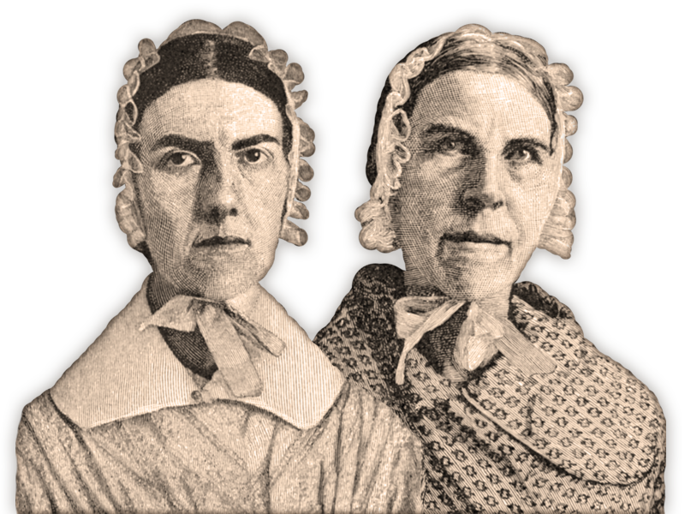

WHAT ELSE?

- The sisters lived to see the end of slavery and the beginning of the women's rights movement.
- Sarah, the older, did not tell anyone when she secretly taught slave children to read, something that violated state law.

- Angelina joined the Philadelphia Female Anti-Slavery Society and wrote letters to newspapers protesting slavery from a woman’s point of view.

- Angelina & Sarah Grimke were the first female speakers in the United States.

- Angelina was more skilled in speaking, while Sarah had more talent in writing - Angelina mesmerized audiences, while Sarah wrote remarkable letters.

- Sarah was nearly 80 when she attempted to vote for the first time, and she died three years later, two days prior to Christmas of 1873.

