FREDERICK DOUGLASS

Background:
Frederick Douglass was born on a plantation in Talbot County, Maryland. His mother was a slave and when Frederick was born, he became a slave, too. His birth name was Frederick Bailey.

Once Douglass had learned to read, he read newspapers and other articles about slavery. He began to form views on human rights and how people should be treated. He also taught other slaves how to read, but this eventually got him into trouble. He was moved to another farm where he was beaten by the slave owner in an effort to break his spirit. However, this only strengthened Douglass' resolve to gain his freedom.
In 1838, Douglass carefully planned his escape. He disguised himself as a sailor and carried papers that showed he was a free black seaman. On September 3, 1838 he boarded a train to the north. After 24 hours of travel, Douglass arrived in New York a free man.
Frederick began to speak at meetings about his experiences as a slave. He was an excellent speaker and moved people with his story. He became famous, but this also put him in danger of being captured by his former slave owners. To avoid being captured, Douglass traveled to Ireland and Britain where he continued to speak to people about slavery.

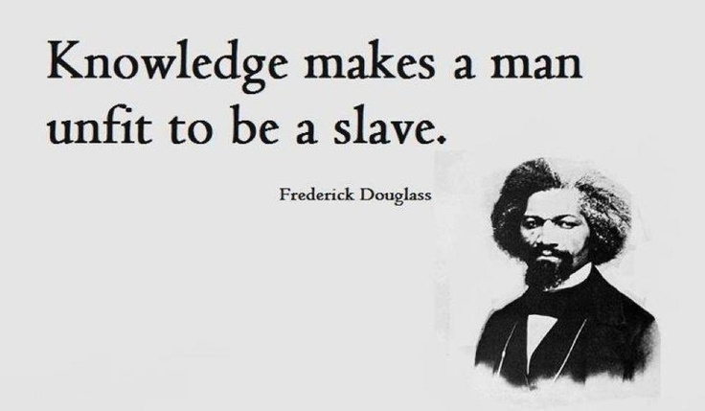

THE NORTH STAR

The North Star, later Frederick Douglass’ Paper, antislavery newspaper published by African American abolitionist Frederick Douglass First published on December 3, 1847, using funds Douglass earned during a speaking tour in Great Britain and Ireland, The North Star soon developed into one of the most influential African American antislavery publications of the pre-Civil War era. The name of the newspaper paid homage to the fact that escaping slaves used the North Star in the night sky to guide them to freedom.

The motto of the newspaper was, “Right is of no sex—Truth is of no color—God is the Father of us all, and we are brethren.”

In the first issue of The North Star, Douglass explained his reasons for establishing an African American-owned newspaper. He emphasized that he did not want to seem ungrateful to people such as William Lloyd Garrison, a white abolitionist who published the antislavery paper The Liberator. However, he claimed that it is common sense that those who suffer injustice are those who must demand redress and, thus, African American authors, editors, and orators must have their own paper with which to share their voices.
Published weekly, The North Star was four pages long and sold by subscription at the cost of $2 per year to more than 4,000 readers in the United States.

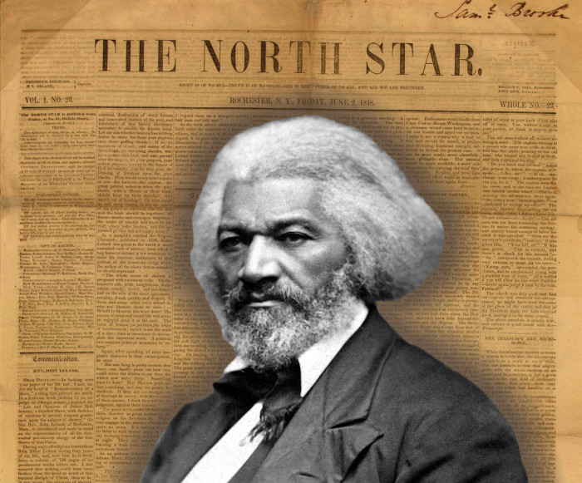

WHAT ELSE?

1. Frederick Douglass was born Frederick Augustus Washington Bailey in 1818.

2. He chose his name from a character in Sir Walter Scott’s The Lady of the Lake.

3. Though Douglass was born a slave, he escaped in 1838 and eventually settled with his wife in New Bedford, Massachusetts.

4. Douglass published his autobiography, Narrative of the Life of Frederick Douglass, an American Slave in 1845.

5. As a strong supporter of the woman’s rights movement, Douglass attended the famous Seneca Falls conference in 1848.

6. Douglass consulted with President Abraham Lincoln during the Civil War and helped influence the Emancipation Proclamation. After President Lincoln’s death, Mrs. Lincoln sent Douglass her late husband’s walking stick.

7. Douglass was nominated for Vice President of the United States as a member of the Equal Rights Party in 1872.

