Public Education Reform

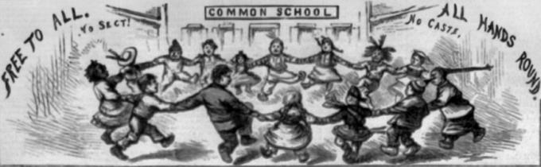

Detail from a Harper’s Weekly cartoon by Thomas Nast, February 26, 1870. (Library of Congress Prints and Photographs Division)

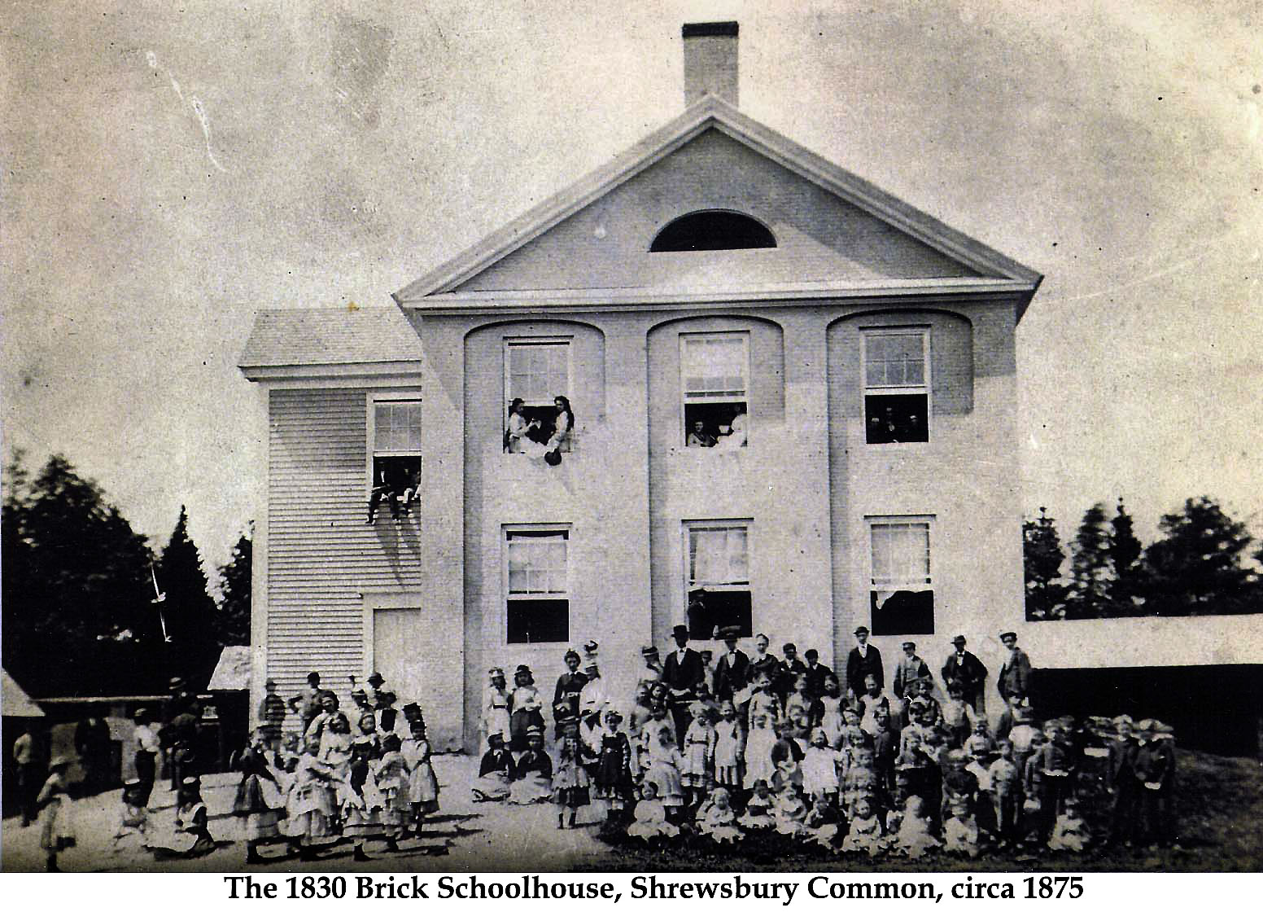

Mental Health/Prison Reform

There were two primary systems of prison reform used in the 19th century: the Pennsylvania System, or Separate System; and the Auburn System, also known as the Silent System.

Pennsylvania System
- 24-hour separation that consisted of work, feeding, and occasional vocational instruction
- Cherry Hill Penitentiary, or the Eastern State Penitentiary, used this system in 1829
- Relied upon solitary confinement as opposed to labor
- New inmates were forced to wear a hood when escorted to their cell, so they wouldn't see other prisoners
- Lockstep and single-file marching were used, with prisoners heads turned to the right
- Visitors, mail, and newspapers were banned
- Some conveniences were central heating, flush toilets, exercise, occupation, and proper sanitation
- Goal was to destroy sense of "criminal community" and encourage penance
- This design was very influential in U.S. history
Auburn System
- Individual sleeping cells, some have been recorded to be about 2 1/2 by 61/2 feet
- Inmates forced to work in shops in silence all day
- Auburn Prison, built in 1821 in Auburn NY, was first of two prisons authorized by New York law of 1816
- Emphasis on individuality in architecture - in order to create an environment to reform and teach criminals habits of order by using discipline
- Prisoners labored 10 hours a day for 6 days a week
- Influenced reform schools and workhouses to open in the 1820s
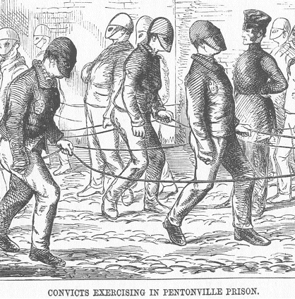
Women's Prison Association (WPA)
This association began as the female department of the Prison Association of New York in 1845. This organization desired separate women's prison quarters and to reform female convicts through religious observance and domestic training. They hoped this would lead to jobs for the women such as housekeepers, nannies, and seamstresses. This department became the WPA in 1853, removing itself from PANY. Accomplishments of this organization consist of passing legislation, advocating for the children of imprisoned mothers, and programs that support families being brought together again.

