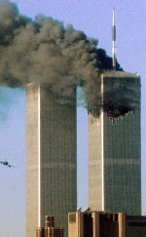
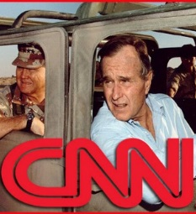
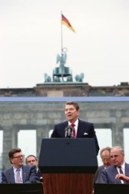
Unit 9: 1980-Present A New World Order

A.P. U.S. History

Key Concepts
 |  |  | You Should Be Able To:
KC 9.1  A newly ascendant conservative movement achieved several political and policy goals during the 1980s and continued to strongly influence public discourse in the following decades. |  |  | - Explain how the Reagan administration represented an important milestone of conservativism, leading to significant tax cuts, the deregulation of many industries, and the end of many liberal programs (e.g. Great Society) (KC 9.1.I.A,C).  - Explain how and why liberals and conservatives argued over free-trade agreements, the size and scope of the federal government, social safety net programs, and how to reform the US financial system (KC 9.1.I.C).
 |  |  | You Should Be Able To:
KC 9.2  Moving into the 21st century, the nation experienced significant technological, economic, and demographic changes. |  |  | - Analyze the impact of communication and technological innovations in computing and digital technology (e.g. the Internet) in social and economic behaviors (KC 9.2.I.A-B).  - Explain the causes and impact of the increase of employment in service industries, as well as the decline in union membership (KC 9.2.I.C).  - Understand the causes and ramifications of growing economic inequality (e.g. stagnation of real wages for working and middle class (KC 9.2.I.D).  - Explain the cultural and political consequences of major demographic shifts after 1980, including the boom of the South and West, and increased immigration from Latin America (KC 9.2.II.A-B).  - Explain the causes and impact of continued debates on immigration policy, gender roles, and family structure (KC 9.2.II.C).
 |  |  | You Should Be Able To:
KC 9.3  The end of the Cold War and new challenges to U.S. leadership forced the nation to redefine its foreign policy and role in the world. |  |  | - Articulate the reason for Reagan’s (and his successors’) interventionist foreign policies, even after the end of the Cold War (KC 9.3.I.A-C)  - Explain how and why Reagan, despite wanting to curtail the size and scope of the federal government, expanded the military and nuclear arsenal in an attempt to oppose and eventually end Communism (KC 9.3.I.A-B)  - Analyze the reasons the Cold War ended (KC 9.3.I.A-B)  - Explain the new international and diplomatic challenges the U.S. faced after the end of the Cold War, as well as the debate over the uses of American power in the world (KC 9.3.I.C)  - Explain the impact the September 11, 2001 attacks had in the U.S., including the lengthy and controversial conflicts in Iraq and Afghanistan (KC 9.3.II.A)  - Analyze how and why the War on Terror sought to improve security, but also raised questions about civil liberties and human rights (KC 9.3.II.B)  - Analyze the U.S. position as the world’s leading superpower despite economic, political, and foreign policy challenges (KC 9.3.II.D)
Thinking Like A Historian
 | Causation… Historians try to understand the causal factors which lead to historical events, as well and what results from those events. They might ask, for example, what led to changes in migration after 1980, and how did the U.S. respond to those changes?
 | Comparison… Historians might compare the resurgence of conservativism in the 1980s to the rise of liberalism in the 1960s and determine why each movement occurred and what the differences were.
 | Comparison… Historians try to understand specific historical events by examining different perspectives. For example, historians might compare the writings of a traditionalist like Phyllis Schlafly to writings by feminist Gloria Steinem to draw conclusions about what was happening culturally at that time.

A.P. U.S. History

Terms, People, and Concepts (No cards are assigned BUT you are responsible for these terms :

“stagflation”
OPEC oil embargo
Election of 1980
Iranian hostage crisis
Ronald Reagan
Moral Majority
Focus on the Family
“Star Wars” (SDI)
Grenada
Iran-Contra Deal
The Moral Majority
Immigration Reform & Control Act of 1986
Berlin Wall removed
Breakup of USSR
Reaganomics/ Supply Side Economics
Sandra Day O’Connor
AIDS
George H.W. Bush
Operation Desert Storm
Affirmative Action
Election of 1992
Contract with America
Planned Parenthood v. Casey
Bill Clinton
“Don’t Ask, Don’t Tell” debate
North American Free Trade Agreement,
George W. Bush
9/11
Barack Obama

The following questions have been asked as AP Free Response (FRQ) and Document Based Questions (DBQ) on this unit.

- Explain how U.S. military and economic involvement in the developing world and issues such as terrorism and economic globalization have changed U.S. foreign policy goals from the 1980s through the 21st century.
- How did TWO of the following bring benefits to some Americans and burdens to others?
  - globalization
  - technological changes
  - economic changes

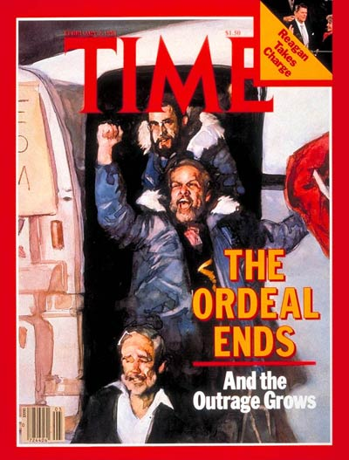
A.P. U.S. History
Unit 1: 1491-1607

Unit 1: 1491-1607

