A.P. U.S. History | 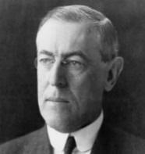  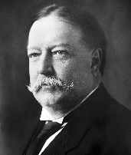  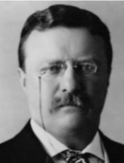  Unit 7A: 1890-1920 Imperialism and Progressivism
 | Key Concepts
 |  |  |  | You Should Be Able To Explain:
 | KC 7.1  Growth expanded opportunity, while economic instability led to new efforts to reform U.S. society and its economic system. |  |  | - Explain the reasons for and impact of the transition from a rural, agricultural economy to an urban, industrial economy focused on production of consumer goods, improved standards of living, and better communications systems (KC 7.1.I.A).  - Analyze the ways in which urban centers (by 1900) offered new economic opportunities for women and immigrants (KC 7.1.I.B).  - Explain how credit and market instability (particularly during the Great Depression) led to a stronger financial regulatory system (KC 7.1.I.C).  - Explain how and why political corruption, economic instability, and social concern for working classes, immigrants, and the environment led to Progressive efforts to reform the government and society (KC 7.1.I.A-C).  - Explain the ways in which Progressive reformers were divided among themselves about goals and methods (KC 7.1.II.D).  - ‘Explain how and why the Great Depression transformed the U.S. into a limite4d welfare state with a series of reforms and regulatory agencies under the leadership of FDR and the New Deal (KC 7.1.III.A-C).  - Explain the growth of populist and labor movements, and the conservative reaction to them (KC 7.1.II.B).
 |  |  |  | You Should Be Able To Explain:
 | KC 7.2  Innovations in communications and technology contributed to the growth of mass culture, while significant changes occurred in internal and international migration patterns. |  |  | - Explain how and why new technologies (e.g. radio, cinema) led to cultural changes and debates over values, morals, and national identity (KC 7.2.I.A).  - Explain how modernism, gender roles, science, religion, race, and immigration emerged as dominant issues between 1890-1945 (KC 7.2.I.D).  - Explain the connection between migration and cultural movements like the Harlem Renaissance, as well as increased debates over civil liberties during and after WWI (KC 7.2.I.B-C).  - Explain demographic changes and migration patterns (domestic and international) around WWI (KC 7.2.II.A).  - Analyze the role of race in American culture, politics, and economics before, during and after WWI (KC 7.2.II.B-D).
 |  |  |  | You Should Be Able To Explain:
 | KC 7.3  Participation in a series of global conflicts propelled the U.S. into a position of international power while renewing domestic debates over the nation’s proper role in the world. |  |  | - Explain how and why U.S. imperialist policy created economic opportunity, stimulated nativism and isolationist attitudes, and led to debates over America’s role in the world (KC 7.3.I.A-C, 7.3.II.A-D).  - Analyze U.S. entrance into and participation in WWI, as well as the war’s impact on foreign policy (KC 7.3.II.A-D).  - Explain how and why the U.S. entered WWII (KC 7.3.II.E, 7.3.III.A).  - Analyze the impact of WWII on the U.S., including the mass mobilization of the economy, technological and scientific advances, and how and why the U.S. emerged as the most powerful nation on earth (KC 7.3.III.A-E).  - Assess the impact of challenges to civil liberties during WWII (e.g. Japanese-American internment) (KC 7.3.III.C).
 | Thinking Like A Historian
 |  | Synthesis… Historians look for connections between historical events in different times and places. They might ask, “How did the Spanish American Revolution connect to the events of the Cold War?”
 |  | Comparison… Historians might compare the migration patterns after WWI to those of the Industrial Age.
 |  | Causation… Historians are likely to analyze the factors which led to U.S. involvement in WWII. They might try to determine the most important, and least important, factors which caused the U.S. to enter the war.
A.P. U.S. History

Terms, People, and Concepts:
COMPLETE FLASH CARDS FOR ALL OF THE FOLLOWING |  | CHOOSE FIVE MORE
- Spanish-American War  - Yellow Journalism  - Commodore George Dewey  - U. S. S. Maine  - DeLome Letter  - Treaty of Paris  - Gentleman’s Agreement  - “Big Stick” Policy  - Roosevelt Corollary  - Open Door Policy  - Dollar Diplomacy  - Jingoism  - Teller Amendment  - Platt Amendment  - Rough Riders  - Admiral Mahan  - Panama (Canal)  - Primary  - Initiative  - Referendum  - Recall  - Robert LaFollette  - Eugene Debs  - William McKinley  - Theodore Roosevelt  - Bull Moose Party  - Square Deal  - Pure Food and Drug Act  - Meat Inspection Act  - Upton Sinclair  - The Jungle | - “Trust-busting”  - William Howard Taft  - Woodrow Wilson  - New Freedom  - Clayton Anti-Trust Act  - Federal Reserve Act  - Federal Trade Commission  - 16th Amendment  - 17th Amendment  - 18th Amendment  - 19th Amendment  - Ida Tarbell  - Secret Ballot  - W. E. B. DuBois  - Booker T. Washington  - N. A. A. C. P.  - Submarine Warfare (U Boats)  - Lusitania  - Zimmerman Note  - Espionage and Sedition Acts  - Schenck v. U. S.  - Selective Service  - 14 Points  - League of Nations  - Versailles Treaty  - Henry Cabot Lodge  - Doughboys  - John J. Pershing  - Big Four | Northern Securities Case  City Managers  Imperialism  Anti-Imperialist League  “White Man’s Burden”  New Nationalism  Conservationism  Niagara Movement  Hepburn Act  Payne-Aldrich Tariff  Mann Act  Child Labor Act  Underwood-Simmons Tariff  Lincoln Steffens  Frank Norris  The Octopus  Margaret Sanger  Pinchot-Ballinger Scandal  Commodore Perry  Hay Treaty (Panama)  Moral Diplomacy  Insular Cases  Josiah Strong  Neutrality Rights  Sussex Pledge  Public Information Committee

The following questions have been asked as AP Free Response (FRQ) and Document Based Questions (DBQ) on this unit.
- Describe and account for the rise of nativism in American society from 1900 to 1930.
- To what extent did the United States achieve the objectives that led it to enter the First World War?
- To what extent and why did the United States adopt an isolationist policy in the 1920s and 1930s?
- To what extent was late nineteenth-century and early twentieth-century United States expansionism a continuation of past United States expansionism and to what extent was it a departure?
- Analyze the ways in which state and federal legislation and judicial decisions, including those of the Supreme Court, affected the efforts of any TWO of the following groups to improve their position in society between 1880 and 1920.
- African-Americans
- Farmers
- Workers

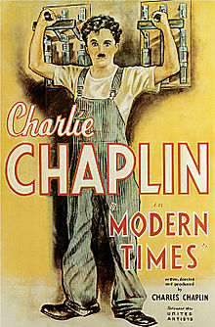

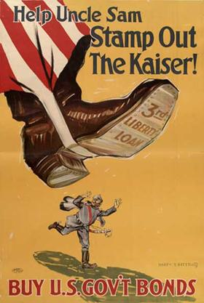
A.P. U.S. History
Unit 1: 1491-1607

Unit 1: 1491-1607

