Key Concepts
 |  |  | You Should Be Able To Explain:
KC 4.1  The US began to develop a modern democracy and celebrated a new national culture, while Americans sought to define the nation's democratic ideals and change their society and institutions to match them. |  |  | - Explain how participatory democracy expanded to all adult, white men (KC 4.1.I).  - Explain how and why political parties addressed issues such as tariffs, internal improvements, the scope of federal powers, and foreign relations (KC 4.I.I.A-C)  - Explain how and why the Democratic Party emerged, the Supreme Court took on an expanding role, and regionalism became a political factor in the 1830s (KC 4.1.I.C).  - Explain the development of the Market Revolution and how it led to economic, social, and geographic mobility, the 2nd Great Awakening, and moral, social, and religious reforms (KC 4.1.II.A).  - Explain the development of artistic and religious movements after 1800 as well as ways in which enslaved and free African-Americans created communities and strategies to protect family structures and change their political status (KC 4.1.II.C-D).  - Explain the causes and effects of the temperance, abolitionist, and women’s' rights movements (KC 4.1.IIIA-C).
 |  |  | You Should Be Able To Explain:
KC 4.2  Innovations in technology, agriculture, and commerce powerfully accelerated the American economy, precipitating profound changes to US society and the national and regional identities. |  |  | - Explain the impact of the Market Revolution and early industrialization on America (KC 4.2.I.A-B).  - Articulate the ways in which the federal government supported the growth of the Market Revolution (KC 4.2.I.C).  - Explain the impact of the Market Revolution on the working class, farmers, the middle class, elites, as well as on gender and the family (KC 4.2.II.A-C).  - Explain migratory changes during the Market Revolution (KC 4.2.III.A).  - Explain the impact of the Market Revolution on the South, as well as the growth of sectionalism (KC 4.2.III.B-D).
 |  |  | You Should Be Able To Explain:
KC 4.3  The US interest in increasing foreign trade and expanding its national borders shaped the nation's foreign policy and spurred government and private initiatives. |  |  | - Explain the changing global presence of the U.S. with the Monroe Doctrine, acquisition of new territories, and continued subjugation of Native populations (KC 4.3.II.A-C).  - Explain continuing debates over slavery, especially the expansion of slavery into new territories and attempts at legislative compromise (KC 4.3.II.A-C).
Thinking Like A Historian
 | Causation… Historians try to evaluate the reasons events happen, and what factors contributed to patterns and trends. They might ask, “What factors led to the development of the Market Revolution?”
 | Periodization… Historians try to understand the common characteristics of a time period. They might try to identify the predominant features which shaped the Jacksonian period, for example.
 | Contextualization… Historians might evaluate the context in which a source is read or understood. They might, for example, look at how the Declaration of Rights and Sentiments was shaped by the events of the Market Revolution.
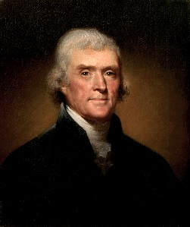
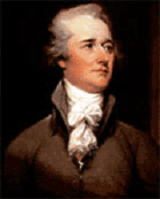
Unit 4: 1800-1848 Democracy, Nationalism,
and Expansion in the Early Republic

A.P. U.S. History

A.P. U.S. History

Terms, People, and Concepts:
By FRIDAY April 7, 2017: COMPLETE FLASH CARDS FOR ALL OF THE FOLLOWING (using your AMSCO book, text book, notes, and any other resources)
COMPLETE FLASH CARDS FOR ALL OF THE FOLLOWING |  | CHOOSE FIVE MORE
- Election (“Revolution) of 1800  - Thomas Jefferson  - Republican Motherhood  - Cult of domesticity  - Louisiana Purchase  - Lowell System  - Eli Whitney  - Samuel Slater  - Nullification  - John Marshall  - Marbury v. Madison  - Impressment  - Hartford Convention  - James Madison  - James Monroe  - Monroe Doctrine  - Era of Good Feelings  - Whigs (National Republicans)  - Democrats  - Know-Nothings  - Spoils System  - Specie circular  - Panic of 1837  - John C. Calhoun  - Henry Clay  - Daniel Webster  - 2nd Bank of the U.S  - Transcendentalism  - Second Great Awakening  - Abolitionist Movement | - Charles Finney  - Temperance  - Seneca Falls Convention/ Declaration of Sentiments  - William Lloyd Garrison  - Sojourner Truth  - Frederick Douglass  - Election of 1824 (corrupt bargain)  - John Quincy Adams  - Andrew Jackson  - Pet Banks  - Gibbons v. Ogden  - American System  - Erie Canal  - Worcester v. Georgia  - Trail of Tears  - Force Bill  - Missouri Compromise  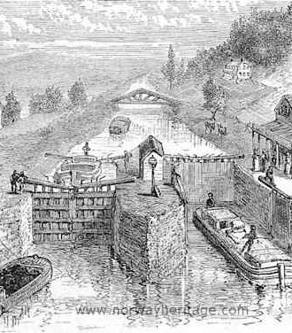 | Embargo Act of 1807  Chesapeake Affair  War Hawks  Non-Intercourse Act  Treaty of Ghent  National Road  Tariff of 1816  Compromise Tariff of 1833  Adams-Onís Treaty  Robert Fulton  Tallmadge Amendment  Burned Over District  Peggy Eaton  “Kitchen” cabinet  Brook Farm  New Harmony  Shakers  Mormons  Joseph Smith  Brigham Young  James Fenimore Cooper  Walt Whitman  Herman Melville  Edgar Allan Poe  Henry David Thoreau  Ralph Waldo Emerson  Hudson River School

Unit 1: 1491-1607

