Key Concepts
 |  |  | You Should Be Able To Explain:
KC 3.1  British attempts to assert tighter control over its North American colonies and the colonial resolve to pursue self-government led to a colonial independence movement and the Revolutionary War. |  |  | - Explain how and why the French and British rivalry in the mid 18th century intensified and threatened trade networks in the Americas and Indian autonomy (KC 3.1.I.A).  - Explain how Britain was able to secure its territorial holdings in the Americas, but at great expense (KC 3.1.I.A-B).  - Articulate reasons for colonial resistance to British imperial policy, particularly with respect to taxation and self-rule (KC 3.1.II.A-B).  - Explain how and why American independence was achieved despite overwhelming odds against it (KC 3.1.I.C-E).
 |  |  | You Should Be Able To Explain:
KC 3.2  The American Revolution’s democratic and republic ideals inspired new experiments with different forms of government. |  |  | - Articulate the ways in which the Enlightenment influenced the American Revolution (KC 3.2.1.A).  - Explain how and why the American Revolution was grounded in republicanism and democracy (KC 3.2.I.A-C).  - Explain the idea of Republican Motherhood, and how and why the American Revolution influenced independence movements abroad (KC 3.2.I.D-E).  - Assess the similarities and differences between the Articles of Confederation and the Constitution (KC 3.2.II.A-C).  - Explain the debate over ratification of the Constitution (KC 3.2.II.D-E).  - Discuss the administrations of Washington and Adams, as well as the formation of the first political parties (KC 3.2.III.A).  - Explain the issues facing the new nation: federalism, economic policy, foreign policy, slavery, and national identity (KC 3.2.III.B-D).
 |  |  | You Should Be Able To Explain:
KC 3.3  Migration within North America and competition over resources, boundaries, and trade intensified conflicts among peoples and nations. |  |  | - Explain how the native populations repeatedly evaluated and adjusted their alliances with Europeans, other tribes, and the U.S. (KC 3.3.I.A).  - Analyze the impact of increasing numbers of immigrants entering the U.S., as well as westward expansion (KC 3.3.I.A-C).  - Explain the impact of U.S. development on native populations (KC 3.3.I.D).  - Explain how the Spanish continued to influence the Southwest (KC 3.3.I.E).  - Evaluate U.S. foreign relations as the U.S. established a world presence (KC 3.3.II.A-C).
Thinking Like A Historian
 | Synthesis… Historians look for connections between historical events in different times and places. They might ask, “How did the American Revolution impact the events of the French Revolution?”
 | Periodization… Historians might ask: “Which date better represents the beginning of the United States as a nation, 1776 (the signing of the Declaration of Independence) or 1787 (ratification of the Constitution)?”
 | Contextualization… Historians try to place specific events within larger processes. They might try to understand how the Enlightenment impacted the events of the American Revolution.
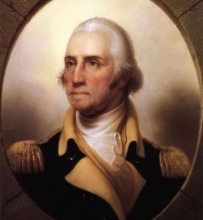
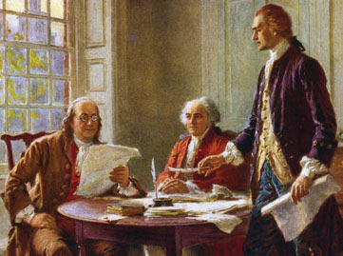
Unit 3: 1754-1800 Origins of the
American Republic

A.P. U.S. History

A.P. U.S. History

APUSH REVIEW VOCAB PERIOD 3: 1754-1800
Origins of the American Republic
By FRIDAY March 31, 2017: COMPLETE FLASH CARDS FOR ALL OF THE FOLLOWING (using your AMSCO book, text book, notes, and any other resources) |  | CHOOSE FIVE MORE!
Iroquois Confederation  Proclamation of 1763  Stamp Act  Actual Representation  Virtual Representation  Townshend Acts  Tea Act  Boston Massacre  Committees of Correspondence  Intolerable Acts  Sons of Liberty  John Locke  Voltaire  Adam Smith  Kentucky and Virginia Resolutions  Shays’ Rebellion  Albany Plan of Union  John Adams  James Madison  Alien and Sedition Acts  X, Y, Z Affair  Jay’s Treaty  Pinckney’s Treaty  Separation of Powers  Elastic Clause | Judicial Review  Checks and Balances  Bill of Rights  Federalists/Hamiltonians  Anti-Federalists/ Jeffersonians  Amendment Process  Executive Branch  Legislative Branch  Judicial Branch  Robert Morris  Thomas Jefferson  Benjamin Franklin  George Washington  Articles of Confederation  Alexander Hamilton  Hamilton’s Financial (Assumption) Plan  Whiskey Rebellion  Bank of the U.S.  Critical Period  Great Compromise  3/5ths Compromise  Electoral College  Federalism | Molasses Act  Paxton Boys  Mercy Otis Warren  Pennsylvania Constitution of 1776  Pontiac’s Rebellion  Proclamation of Neutrality  Report on Manufactures  Jean-Jacques Rousseau  Montesquieu  Delegated Powers  Concurrent Powers  Denied Powers  Implied Powers  Reserved Powers  Strict/ Loose Constructionism

Unit 1: 1491-1607

