A.P. U.S. History

APUSH REVIEW VOCAB PERIOD 1: 1491-1607
A NEW WORLD?
By FRIDAY March 17, 2017: COMPLETE FLASH CARDS FOR ALL OF THE FOLLOWING (using your AMSCO book, text book, notes, and any other resources) |  |  | CHOOSE FIVE MORE!
- Mesoamerica  - Amerindian  - Cahokia  - Mississippian Culture  - Pueblo Indians  - Iroquois (Haudenosaunee)  - Atlatl  - St. Augustine  - Bartolomé de las Casas  - Creolization of culture  - Mayans | - Moctezuma  - Aztecs  - Incas  - Sir Walter Raleigh  - Treaty of Tordesillas  - Encomienda  - Cartier  - De Soto  - Hernán Cortés  - Cabeza de Vaca  - Columbian Exchange |  | John Cabot  Vespucci  Verrazzano  Ponce de Leon  Aztecs  Champlain  Marquette  Joliet  Fort Caroline
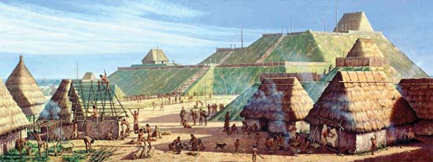
Cahokia
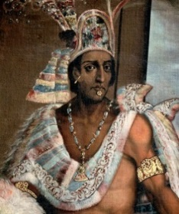
Period 1: 1491-1607 A New World?

A.P. U.S. History

Key Concepts
 |  | You Should Be Able To Explain:
KC 1.1  As native populations migrated across the vast expanse of North America over time, they developed distinct and increasingly complex societies by adapting to and transforming their diverse environments. |  | - Explain how and why the spread of maize cultivation in the Americas supported economic development, settlement, advanced irrigation, and social diversification (KC 1.1.I.A).  - Explain how and why the native peoples of the Great Basin and Great Plains developed largely mobile lifestyles (KC 1.1.I.B).  - Explain how and why the natives in the Northeast and Mississippi River Valley developed mixed agricultural and hunter-gatherer economies which favored the permanent villages (KC 1.1.I.C).  - Explain how and why the natives in the Northeast and Mississippi River Valley developed mixed agricultural and hunter-gatherer economies which favored the permanent villages, while the tribes in the West and Northwest leveraged ocean resources for survival (KC 1.1.I.C-D).
 |  | You Should Be Able To Explain:
KC 1.2  Contact among Europeans, Native Americans, and Africans resulted in the Columbian Exchange and significant social, cultural, and political changes on both sides of the Atlantic Ocean. |  | - Explain what motivated Europeans to establish colonies in the western hemisphere (KC 1.2.I.A).  - Explain how the Columbian exchange impacted the lives of natives and Europeans (KC 1.2.I.B).  - Explain how new economic developments (e.g. joint-stock companies) and technological improvements fueled the development of the Americas (KC 1.2.I.C).  - Explain the impact of disease on native and European people (KC 1.2.II.A).  - Explain what motivated Europeans to establish colonies in the western hemisphere (KC 1.2.I.A).  - Explain how the encomienda system structured labor around plantation-based agriculture and led to a caste system which impacted European, Africans, and Native Americans (KC 1.2.II.B, D).  - Explain how and why African slavery was developed in the Americas, and the impact it had on Africans, Europeans, and native peoples (KC 1.2.II.C).  - Explain how cultural, economic, religious, and political misunderstandings between Native Americans and Europeans led to conflict, cooperation, and competition regarding issues such as religion, gender roles, family, land use, and power (KC 1.2.III, A-C).

