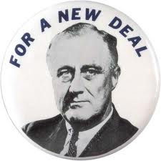
The G r e a t D e p r e $$i o n
A n d T h e N e w D e a l , 1929-1939
APUSH Review Guide for AMSCO chapter 24. Students who do not have the AMSCO guide may use Pearson chapter 22 or other resources for the Great Depression Era.

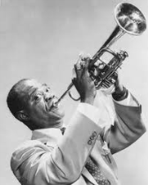
Directions Print document and take notes in the spaces provided. Read through the guide before you begin reading. This step will help you focus on the most significant ideas and information as you read.

Learning Goals:
Identify and analyze the causes and effects of the Great Depression.
Analyze the ways Americans and government responded to the economic depression.
Assess the extent to which the New Deal successfully solved the problems facing Americans during the Great Depression.

Key Concepts FOR PERIOD 7:
Key Concept 7.1: Growth expanded opportunity, while economic instability led to new efforts to reform U.S. society and its economic system.
Key Concept 7.2: Innovations in communications and technology contributed to the growth of mass culture, while significant changes occurred in internal and international migration patterns.
Key Concept 7.3: Participation in a series of global conflicts propelled the United States into a position of international power while renewing domestic debates over the nation’s proper role in the world.

Guided Reading… Introduction, page 496

- After reading the first 3 paragraphs for chapter 24, explain the local and broad context of The Great Depression. Remember in your essay writing… the contextualization of your topic must be thoroughly explained with several sentences! Show that you have mastered this skill!

Local context… facts about the event, describing who/what/when etc.
Broad context… the bigger picture, theme, era, why/how

Causes and Effects of the Depression, 1929-1939, pp 496-498

- Prompt: Explain why business cycle fluctuations became increasingly severe, resulting in the Great Depression.
Main Ideas | Notes/Explanations/Definitions | Analysis
Answer: Even as economic growth continued, episodes of credit and market instability, most critically the Great Depression, led to calls for the creation of a stronger financial regulatory system.  - Stock Market Crash & Burn  -uneven distribution of income  -speculation & buying on margin  -buying on credit  -overproduction  -weak agricultural sector  -tight money policy of Fed.  -lack of regulation  -global economic problems  -Treaty of Versailles  b. Effects | Causes and Effects of the Depression, 1929-1939…  Wall Street Crash…  Black Thursday and Black Tuesday…  Causes of the Crash…  Uneven Distribution of Income…  Stock Market Speculation…  Excessive Use of Credit…  Overproduction of Consumer Goods…  Weak Farm Economy…  Government Policies…  Global Economic Problems…  Effects… | Explain why the causes of the Great Depression led to calls for government action and reform.  To what extent was idealism about American prosperity and the American dream responsible for the Crash? Defend your answer.  Of the effects discussed on pages 498-499, which one is the most significant in leading to dramatic and far-reaching reform in the next decade? Explain your reasoning.
Hoover’s Policies, pp 500-501

- Prompt: How did Hoover respond to the economic downturn?

Main Ideas | Notes/Explanations/Definitions | Analysis
Answer: National, state, and local reformers responded to economic upheavals, laissez-faire capitalism, and the Great Depression by transforming the U.S. into a limited welfare state. However, President Herbert Hoover did “too little too late” and was unsuccessful in providing effective government response to the crisis.  - Rugged individualism  - Increased tariffs  - Debt moratorium  - FFB  - RFC | Hoover’s Policies…  Responding to a Worldwide Depression…  Hawley-Smoot Tariff, 1930  Debt Moratorium…  Domestic Programs: Too Little, Too Late…  Federal Farm Board…  Reconstruction Finance Corporation (RFC)…  Despair and Protest…  Unrest on the Farms…  Bonus March…  The Election of 1932…  Democrats…  Results…  Hoover as “Lame-Duck” President… | Explain why the 20th Amendment was ratified.  Explain how Harding and Coolidge may have addressed the causes and issues that Hoover addressed “too little too late.”  Defend, Support, or Modify the following statement, “The Hawley-Smoot Tariff was the greatest example of modern stupidity since the American refusal to join the League of Nations.”

Franklin D. Roosevelt’s New Deal, pp 502-507

- Prompt: To what extent was Roosevelt’s New Deal an expansion of Progressivism?

Main Ideas | Notes/Explanations/Definitions | Analysis
Answer: The liberalism of President Franklin Roosevelt’s New Deal drew on earlier progressive ideas and represented a multifaceted approach to both the causes and effects of the Great Depression, using government power to provide relief to the poor, stimulate recovery, and reform the American economy.  - Fireside Chats  - First Hundred Days  -21ST Amendment  -Emergency Banking Relief Act  -Glass Steagel Act  / FDIC  -HOLC  -Farm Credit -Administration  Continued on next page… | Franklin D. Roosevelt’s New Deal…  FDR: The Man…  Disability…  Eleanor Roosevelt…  New Deal Philosophy…  Three R.’s:  Brain Trust and Other Advisers…  First Hundred Days…  Bank Holiday…  Repeal of Prohibition…  Fireside Chats…  Financial Recovery and Reform Programs…  . | Describe the significance of FDR’s ability to inspire people and Eleanor Roosevelt’s ability to empathize with people?  Why did Congress support every idea FDR had in the First Hundred Days despite them being radical change?  Of the Financial Reforms, which was the most significant long term? Defend your answer.
Main Ideas | Notes/Explanations/Definitions | Analysis
Prompt: To what extent was Roosevelt’s New Deal an expansion of Progressivism?  Answer Continued…  The liberalism of President Franklin Roosevelt’s New Deal drew on earlier progressive ideas and represented a multifaceted approach to both the causes and effects of the Great Depression, using government power to provide relief to the poor, stimulate recovery, and reform the American economy.  - RELIEF & RECOVERY  -FERA  -PWA  -CCC  -TVA  -NRA  -AAA  -CWA  -SEC  -FHA  -WPA  -RA  b. REFORMS  -Wagner Act  -REA  -Revenue Act  -Social Security  Act | Relief for the Unemployed…  Industrial Recovery Program…  Farm Production Control Program…  Other Programs of the First New Deal…  The Second New Deal…  Relief Programs…  The Election of 1936… | Were any of FDR’s actions during his First Hundred Days found to be unconstitutional? List and explain.  Was the Second New Deal better than the first? Explain your reasoning.

Opponents of the New Deal, pp 508-510

- Prompt: Analyze opposing viewpoints to the radical changes taking place in the United States government.

Main Ideas | Notes/Explanations/Definitions | Analysis
Answer: Radical, union, and populist movements pushed Roosevelt toward more extensive reforms, even as conservatives in Congress and the Supreme Court sought to limit the New Deal’s scope.  - Not Enough!  -Socialists  -extreme liberals  -women  -minorities  -Father Charles E. Coughlin  -Dr. Francis E. Townsend  -Huey Long  - Too Much!  -business  -American Liberty League  -Supreme Court (at first) | Opponents of the New Deal…  Liberal Critics…  Conservative Critics…  Demagogues…  Father Charles E. Coughlin…  Dr. Francis E. Townsend…  Huey Long…  The Supreme Court…  Court Reorganization Plan…  Reaction…  Aftermath… | Support, Refute, or Modify the following statement: The New Deal was revolutionary because it created a much more powerful central government, increased power to the executive branch, and began the modern welfare state. (skip to page 514 and read “Historical Perspectives” before answering.)  Defend your viewpoint with specific evidence.  In response to FDR’s Court Reorganization Bill Sen. Burton K. Wheeler (D-Montana) said, "Every despot has usurped the power of the legislative and judicial branches in the name of the necessity for haste to promote the general welfare of the masses—and then proceeded to reduce them to servitude."  Support, Refute, or Modify the following statement: Checks and Balances successfully prevented Franklin Roosevelt from becoming a tyrant.  Trivia Break:  Following the Court Packing plan, the swing vote of Justice Owen Roberts, began supporting the New Deal; called the "switch in time that saved nine."
Rise of Unions, pp 510-511

- Prompt: Evaluate the ways the New Deal impacted labor?
Highlight Main Ideas in the Background notes, read the pages, then record your notes and analysis below.

Background/Review… In the early 20th century, union membership rose to 6% of the labor force. There were 2.7 million members by 1913, and the share stayed around 6–7% until 1917. This was the "Progressive Era" of 1900 through 1918 which fastened a welfare-warfare state on America which has set the mold for the rest of the twentieth century. From 1842 onward, unions had the clear legal right to exist, and workers could join such "self-help" organizations, but employers were under no obligation to "bargain" with these unions. The courts also tended (ultimately) to restrict union tactics such as threats of violence, violence itself, mob action, and interference with voluntary trade. Further, the courts tended to make little distinction between business and union "restraints on competition." In 1912, Congress supplied new assistance with the Lloyd-LaFollette Act to compel collective bargaining by the US Post Office and encourage postal-union membership. In 1914, Congress passed the Clayton Anti-Trust Act with provisions to exempt unions from the 1890 Sherman Anti-Trust Act, restrict the use of court injunctions in labor disputes and declare picketing and similar union tactics as not unlawful. Samuel Gompers hailed the Clayton Act as labor's Magna Carta, but subsequent court interpretations neutered the pro-union provisions. The "national emergency" of US entry into World War I provided much of the experience and precedent for subsequent intervention on behalf of unionism, as well as for other cartel-like policies. Historian William E. Leuchtenburg, for instance, points out, "The panoply of procedures developed by the War Labor Board and the War Labor Policies Board provided the basis in later years for a series of enactments culminating in the Wagner National Labor Relations Act of 1935." Under pressure of World War I and the government's interventions, union membership skyrocketed, hitting 12% of the labor force. The end of the war ended pro-union interventions. By 1924, the union share of the labor force had slipped to 8%, and by 1933 had eroded to the same 6% as thirty years before.

Main Ideas | Notes/Explanations/Definitions | Analysis
Answer: Although the New Deal did not completely overcome the Depression, it left a legacy of reforms and agencies that endeavored to make society and individuals more secure, and it helped foster a long-term political realignment in which many ethnic groups, African Americans, and working-class communities identified with the Democratic Party. | Rise of Unions…  Formation of the CIO…  Strikes…  Automobiles…  Steel…  Fair Labor Standards Act…  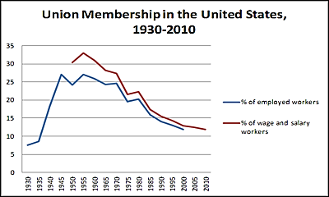 | Consider the bulk of the New Deal.  Would Woodrow Wilson approved?  To what extent was FDR continuing the legacy of Theodore Roosevelt and Woodrow Wilson? Explain and defend your answer.  Why has union member ship declined in recent eras? Ask your parents!  (or Siri)
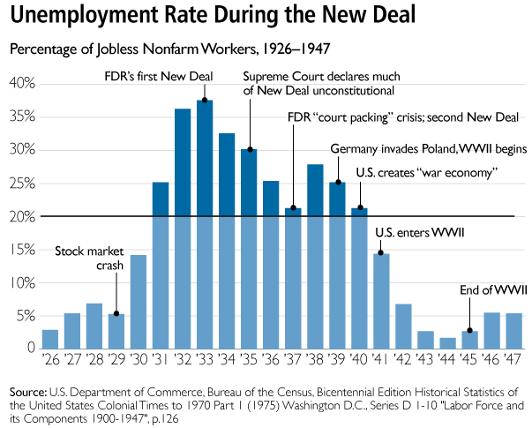

Last Phase of the New Deal, pp 511-512
- Prompt: Evaluate the success (positive impact) of the New Deal.
Main Ideas | Notes/Explanations/Definitions | Analysis
Answer: Although the New Deal did not completely overcome the Depression, it left a legacy of reforms and agencies that endeavored to make society and individuals more secure, and it helped foster a long-term political realignment in which many ethnic groups, African Americans, and working-class communities identified with the Democratic Party.  The mass mobilization of American society to supply troops for the war effort and a workforce on the home front ended the Great Depression and provided opportunities for women and minorities to improve their socioeconomic positions.  Therefore, the New Deal did not succeed in ending the Great Depression, but it did succeed in re-defining the role of government. | Last Phase of the New Deal…  Recession, 1937-1938…  Causes…  Keynesian Economics…  Weakened New Deal… | List three reasons the economy took another downturn (recession of 1937-1938)?  a.  b.  c.  What ended the Great Depression?

Life During the Great Depression, pp 512-513

- Prompt: Analyze the impact of the Great Depression on various groups.

Main Events/Ideas | Definitions/Explanations | Analysis
Answer: Americans who lived through the Great Depression were impacted in profound ways both economically and emotionally.  Many Americans migrated during the Great Depression, often driven by economic difficulties, and during World Wars I and II, as a result of the need for wartime production labor.  Many Mexicans, drawn to the U.S. by economic opportunities, faced ambivalent government policies in the 1930s and 1940s.  - “Depression Mentality”  - Women  -family  -discrimination  -help from New Deal  - Farmers  -Dust Bowl  -jobs  - help from New Deal  - African Americans  -discrimination  -help from New Deal  -social improvements  - Native Americans  -discrimination  -help from New Deal  -social improvements  - Mexican Americans  -discrimination  -Dust Bowl | Life During the Depression…  Women…  Dust Bowl Farmers…  African Americans…  Improvements…  Fair Employment Practices Committee…  American Indians…  Indian Reorganization (Wheeler-Howard) Act (1934)…  Mexican-Americans… | Explain the role First Lady, Eleanor Roosevelt, and Secretary of Labor, Francis Perkins, had in New Deal policies.  Analyze the contributions of Mary McLeod Bethune and the “Black Cabinet,” (Bethune was appointed by FDR to the director of the Office of Minority Affairs in the National Youth Administration).
- Analyze the following primary sources by identifying historical context and purpose or POV. Record your notes to the right of each image.

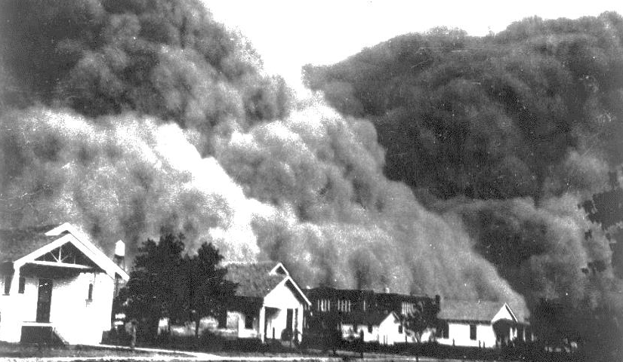
Photograph of dust cloud enveloping neighborhood, 1933

“Let the workers organize. Let the toilers assemble. Let their crystallized voice proclaim their injustices and demand their privileges. Let all thoughtful citizens sustain them, for the future of Labor is the future of America.”
John L. Lewis, CIO Chairman

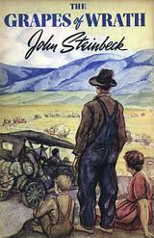

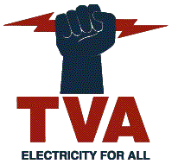

- How was the Great Depression of 1929-1939 different from previous depressions? Complete the chart by adding the missing components.
American Panics and Depressions | Era | Causes | Effects | Significance
Panic and Depression of 1819-1825 | Era of Good Feelings | - Post war drop in demand, prices fall  - Farmers continue to borrow even though market demand isn’t there  - Speculation in western lands  - Contraction of credit, led by Second BUS | - Begins a 6-year depression  - Inspires debate over whether or not the nation should return to specie (hard money) | The Second Bank of the United States, established in 1916, was unable to prevent or remedy the crisis. The issue of national currency became a hot topic.
Panics of 1832 &  1836 &  1837 |  | - Andrew Jackson refuses to renew charter of Second BUS and pulls deposits out (placing them in state/pet banks). Jackson sees the BUS as the root of the evil behind speculation and inflation  - Nicholas Biddle calls in commercial loans in attempt to keep bank afloat, he fails  - After demise of bank, banking anarchy replaces BUS control  - Jackson passes Specie Circular, requiring public lands be paid for in gold or silver (hard money) (it’s rescinded in 1838)  - In response to Specie Circular, banks call in their loans  - Great Britain has a depression causing drop in demand for American cotton… prices fall  - Van Buren continued Jackson’s specie policy and signed a bill requiring all payments to the government to be in gold or silver: Sub Treasury Plan | - 800 banks close  - American banking system collapses  - 33% unemployment in New York  - 10% unemployment nationwide  - land sales drop  - prices drop  - those with specie horde it  - speculators thrive and wildcat banks increase  - Van Buren’s Sub Treasury Plan created sub-treasuries in new York, Boston, Charleston, and St. Louis… a mint in Philadelphia and a branch mint in New Orleans (repealed in 1841 when Congress passed bill for a third BUS but President Tyler vetoed it… twice… all members of his cabinet except Webster resign in protest… Sub Treasury Plan reenacted in 1846) | The Specie Circular (hard money) made economic matters worse, and the Second Bank ended with Jackson’s veto of the re-charter and by removing federal deposits before the bank charter ended in 1836. Jacksonian Democrats did not support a national bank. A Sub-Treasury plan was added, however it was not able to prevent panics.
Panic of 1857 | Antebellum Era | - agricultural exports declined after the end of the Crimean War in Europe  - Over-speculation in railroads and real estate | - Crowds of unemployed flocked into Central Park, threatened authorities, demanded jobs… they were given jobs  - Charities formed and set up soup kitchens  - Started one of the first waves of panic selling on the Stock Market
Panic and Depression of 1869-1871 | Reconstruction Era and early Gilded Age | - Gold was scarce and interest rates high  - Gold was not traded as a commodity (Gold Exchange formed in 1864 for this purpose)  - Railroad speculation was high  - Black Friday, Gold Panic (Fisk and Gould attempted to corner market… Grant dumped 4 million in gold on the market) | - Gold prices fell  - fortunes were lost  - businesses and individuals panicked  - interest in paper currency increased among debtors

American Panics and Depressions | Era | Causes | Effects | Significance
Panic of 1873  and Depression  of 1873-1876 |  | - Jay Cooke and Co. declared bankruptcy (this bank underwrote construction of Northern Pacific RR and helped finance the Civil War)  - Overproduction and over expansion of economy  - Declining market  - Deflation  - European banks (also in depression) called in loans to Americans  - Crime of 73 prevented increase in currency through silver | - Stock Market panic… people sold their stocks  - 10,000 businesses failed  - New York Stock Exchange closed its doors for 10 days  - RR construction declined and some defaulted on their loans  - Unemployed move to cities seeking jobs  - Desperate individuals move west in hopes of finding opportunity  - Interest in silver increased among farmers and workers
Panic of 1893  and Depression of 1893-1897 |  | - Excessive industry and RR speculation  - Philadelphia and Reading RR file for bankruptcy  - McKinley Tariff of 1890 and decreased exports  - Grain, cotton, steel, and timber prices fall  - European banks sell their American stocks and bonds  - Public runs on banks | - J.P. Morgan warns President Cleveland of the panic and urged him to repeal the Sherman Silver Purchase Act of 1890… it is repealed but does not stop the depression which is worldwide  - 500 banks failed  - Coxey’s Army marched on Washington  - Government borrows 65 million from J.P. Morgan  - Debate over bimetallism increases
Panic of 1901 |  | - Drought  - Public spooked by McKinley’s assassination  - Edward Harriman tries to buy up Northern Pacific stock (already controlled Union Pacific) | - Stock holders panicked and began selling… first major stock market crash for the New York Stock Exchange  - Harriman and his monopoly (Northern Securities Holding Co.) soon broken up under the Sherman Antitrust Act | Progressive reformers sought federal legislation to increase government control of banking and money supply in order to reduce the wild fluctuations of the business cycle. The Federal Reserve Act is passed in 1913, creating our current system, Federal Reserve System.
Panic of 1929  and  “Great”  Depression of 1929-1945 |  | 1.  2.  3.  4.  5.  6.  Other causes: | 1.  2.  3.  4.  5.  6.  Other effects

Reading Guide written by Rebecca Richardson, Allen High School
Sources include but are not limited to: 2015 edition of AMSCO’s United States History Preparing for the Advanced Placement Examination,
2012 and 2015 Revised College Board Advanced Placement United States History Framework, images from WikiCommons, ushistory.org, and other sources as cited in document and collected/adapted over 20 years of teaching and collaborating

