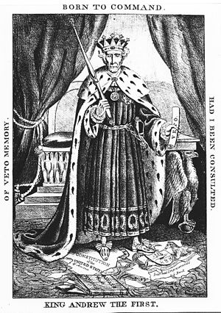
TEMPLATE WRITING EXAMPLE (PURPOSE): The purpose of the political cartoon is to make Andrew Jackson look like an absolute monarch and abuser of power.
MORE SOPHISTICATED EXAMPLE (PURPOSE): The cartoon intends to expose President Jackson as an absolute monarch rather than be limited by the U.S. Constitution.
TEMPLATE WRITING EXAMPLE (POV): The point of view of the artist is he is critical of Andrew Jackson since he drew him as a king and destroyer of the Bank.
MORE SOPHISTICATED EXAMPLE (POV): The portrayal of Jackson as an absolute monarch stems from a pro-Whig advocate of the Bank of the United States.
TEMPLATE WRITING EXAMPLE (AUDIENCE): The intended audience is people who do not like Jackson as an abuser of power.
MORE SOPHISTICATED EXAMPLE (AUDIENCE): The cartoonist appealed to potential undecided voters to garner support for the Whig candidate by criticizing Jackson's abuse of power.

TEMPLATE WRITING EXAMPLE (HISTORICALCONTEXT): The historical context is there is the Election of 1832 between the Jackson Democrats and Whig Party.
MORE SOPHISTICATED EXAMPLE (HISTORICAL CONTEXT): The Election of 1832 pitted the Jackson Democrats campaigning for the common man against the Whigs who supported national policies, such as a national bank and protective tariffs.

