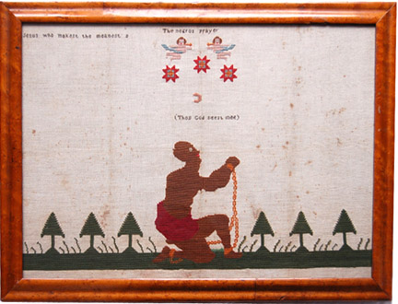
Organizing large fundraising fairs was a popular way for women to support the anti-slavery cause. It was at one such Massachusetts fair in 1836 that organizers sold an Abolition quilt, the earliest known fundraising quilt. The 8-pointed star crib quilt, sometimes attributed to author and activist Lydia Maria Child, included a poem by Quaker poet Elizabeth Margaret Chandler in its center block that included a reminder to think of the slave mother, whose child “was torn from her.”
Existing quilts featuring Abolitionist sentiments are rare, although a small number of anti-slavery quilts made by Quakers are preserved in museums. Of these, several feature the same image, stamped in ink on a white patch, that features a bound slave, kneeling and begging for justice. The image, borrowed from Britain’s Society for the Abolition of the Slave Trade, became an icon of the abolitionist movement on both sides of the Atlantic.
As communication devices and fundraisers alike, these anti-slavery quilts were precursors to the tens of thousands of quilts made by both southern and northern women just a few short decades later, as the Civil War (1861-1865) raged.

